Silk Threads

1234 Silk Court

Mississauga, Ontario L1M 2O3

Canada

9-Dec-2017

Dear Mr. Torino,

I am writing to inform you about the status of the new business system prototype for your company. I am pleased to provide you with a proposed interface design for the web site.

Further to your approval on the new systems requirements report, I am delighted to tell you that your web site design has been confirmed and approved.

I enclose a printed copy of the new systems user interface document for your review and approval. I would appreciate it if you could send me your approval by Monday 17-Dec-2017.

I look forward to meeting you.

Yours sincerely,



**Internal Approval Signatures:**

 9-Dec-2017

_________________________________________________ ______________

Nikola Petrovski Date

**PETROVSKI BUSINESS DEVELOPMENT REPRESENTATIVE**

**Client Approval Signature:**

_________________________________________________ ______________

**Anthony Torino Date**

**SILK THREADS OPERATIONS DIRECTOR**

Table of Contents

1.0 SUMMARY3

2.0 INTRODUCTION4

3.0 MENU STRUCTURE5

4.0 GUI7

5.0 REPORTS12

6.0 RECOMMENDATIONS17

7.0 REVISION HISTORY18

List of Figures

Figure 15

Figure 26

Figure 37

Figure 48

Figure 59

Figure 610

Figure 711

Figure 812

Figure 913

Figure 1014

Figure 1115

Figure 1216

1. **SUMMARY**

A new business system web site development project was assigned to PETROVSKI by Silk Threads. All new systems requirements were identified and approved by both parties. The major proposed changes apply to 5 operational areas in the new integrated system. Based on the earlier business case study, the investigation report, and new system requirements document mock-ups for GUI screens and reports were created. The challenge was to design a brand-new system that does not supersede any existing online system and provide competitive user experience.

The web site will address five new system requirements based on the Silk Threads’ needs. Listed by category, these are the main instances where user interface members are developed.

PROCESS: The website supports transactions to process new sales orders and collaboration window to service sports teams with artistic uniform personalization.

OUTPUT: The generation of reports is provided by Oracle cloud database through a global network of data centers. The fast-selling-item report adds business intelligence to Silk Threads. It tigers reorder process for item that exceed the anticipated sales volume.

INPUT: PDF forms support an interface for digital signature functionality. The online input methods utilize RFID and the new systems include immediate validation and availability of data.

CONTROL: The system generates reports for defective items received and it includes the defect type, description and date. These processing errors can be logged and efficiently analyzed.

PERFORMANCE: Personalization order approval status is shown with interface values: In Progress, Approved, and Cancelled.

1. **INTRODUCTION**

This document contains 4 major sections: Menu Structure, GUI Mock-ups, Reports and Recommendations.

* The first section displays visuals for the Silk Threads’ new business website. It includes screen mockups of the required tables in form of dashboard or menu structure. The navigation flow is depicted by cascading menus that change from one tab to another.
* The second section illustrates each input screen of the new system in form of a prototype. To facilitate successful visualization of the new progressive ideas representative sample data is added to the prototypes. Beside pictorial instructions there is a comprehensive verbose narrative for each screen as well. The GUI screens describe new business requirements such as client profile, order, and customization.
* The Reports section provides examples that summarize the new system requirements. It states the purpose for generating each report. Also, the reports list a sample data to focus on the efficient layouts, clear total documentation and association to the business trade relevance.
* The recommendations section suggests the importance of electronic information produces by the new system and the necessity of automated data entry. It explains the logic behind reaching meaningful information. The next project is generation of cost benefit analysis report.

1. **MENU STRUCTURE**

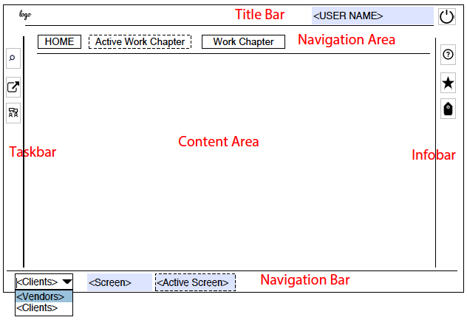 Figure 1: Dashboard screen

1. The *Navigation Area* provides navigation to all Work Chapter views and Work Chapter sub-views.
2. *HOME*: Navigates to the Home Chapter for the general public website similar to Amazon online shopping website.
3. *Work Chapters*: Navigate to Work Chapter views, their sub-views and Common Tasks.
4. *Title Bar*: Allows navigation to Silk Threads Store, user information and login/logoff.
5. *Taskbar*: Allows navigation to Shortcuts, the Collaboration Center and the Business System Search.
6. Infobar: Opens the Info Area which contains the Help Desk, Favorites and Tags.
7. Navigation Bar: Allows navigation between screens.
8. **MENU STRUCTURE (CONTINUED)**

 Figure 2: Content area screen

1. Title: Represents an object identifier. Examples: Sales Order: 123s, Purchase Order: 456p.
2. ID Region: Contains identifying data fields. Examples: Status, Total Net Value, Created On, and Created By.
3. Toolbar Buttons: Release, Save, Close, New.
4. Extra Menu is of a different type than the object dealt with. Examples: Assign Uniform Customizing Resources, Edit Project, Run Cost Center Planning, Open Calendar, and Open Tasks.
5. Basic View: Allows the user to quickly perform a specific task. This is a short sub-task within the context of the object (for example a quick order create).
6. Tabs: The first tab is General, followed by Line Items, Flow, Changes, Notes, Attachments, and Output History.

NOTE: If all sub-tabs do not contain any data, the tab node is disabled.

1. Content: Uses meaningful headers to group fields. Examples: Delivery, Payment and Contact forms, use a two-column layout with single-column section groups.
2. Notes: Provide an additional text field space to the bottom of the view. It uses a group header to label the text field.
3. **GRAPHICAL USER INTERFACES**

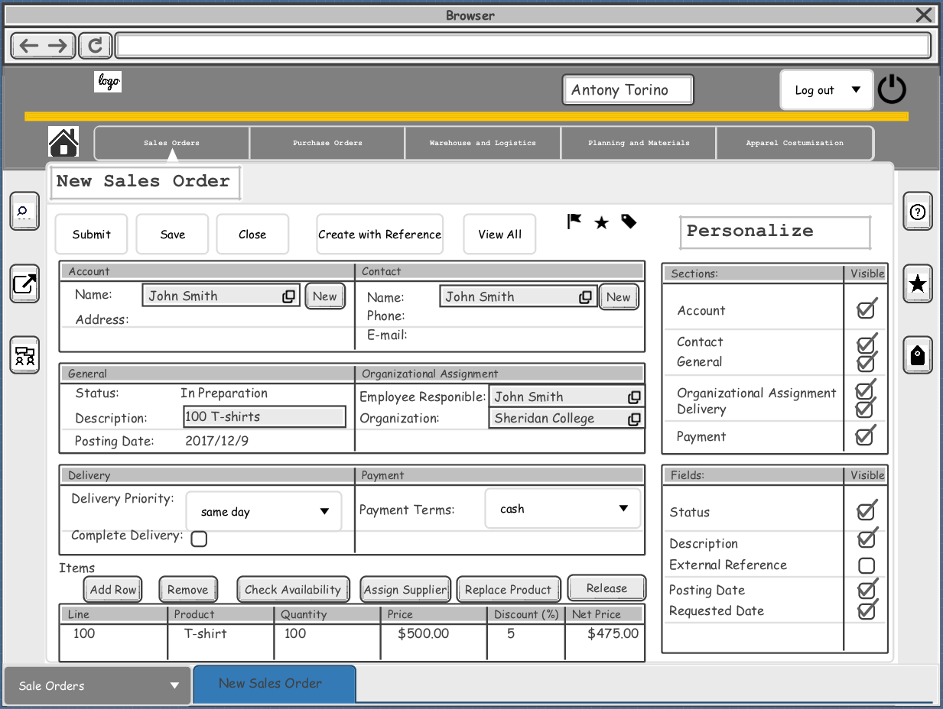 (Figure 3: Submitting Sales Order)

1. Create with Reference is used to create a sales order and selects from the database history an item as a reference.
2. The Personalization area settings allow to hide and show certain sections and fields so the user can personalize several views.
3. **GRAPHICAL USER INTERFACES (CONTINUED)**

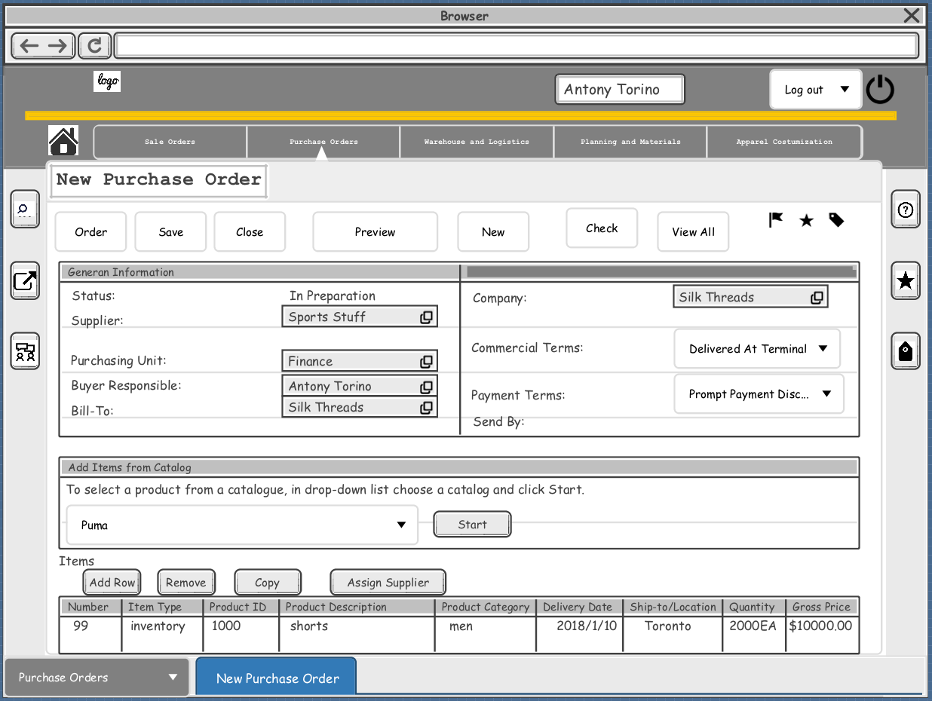 (Figure 4: Submitting Purchase Order)

1. Assign Supplier is used to execute an automatic mass processing of a purchase orders. For example, the invoice clerk can define and run an automator for invoices: The system creates invoices for supplier Sport Stuff on a fast-seller basis without the need for any manual action of the invoice clerk.

**4.0 GRAPHICAL USER INTERFACES (CONTINUED)**

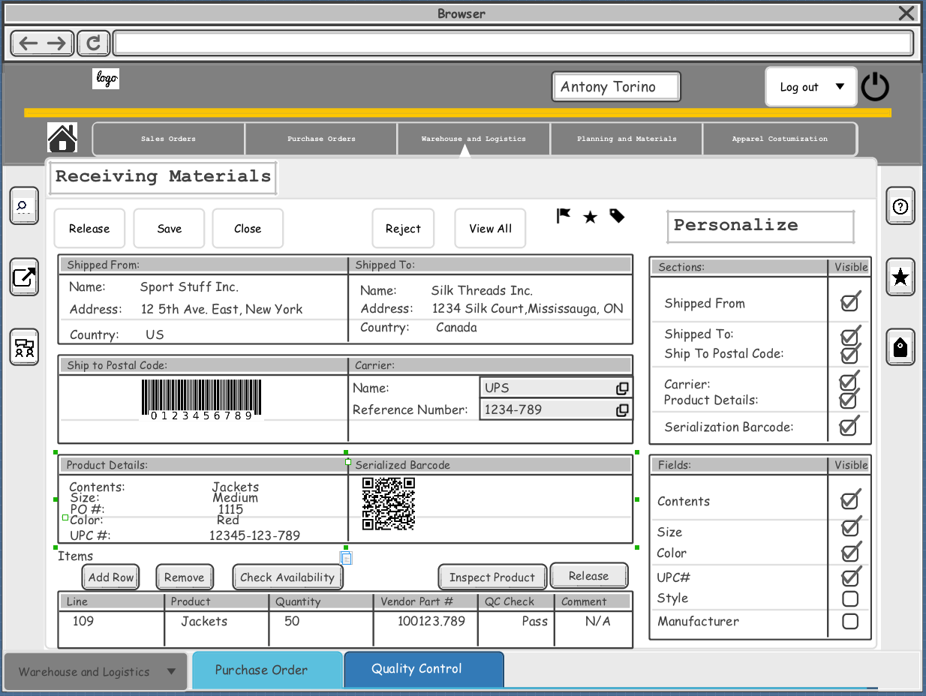 (Figure 5: Receiving Materials)

1. Inspect Product is used to interact with Quality Control. For example, inspection clerk can print this PDF form and perform a visual inspection for defects, damage or quantity received.

**4.0 GRAPHICAL USER INTERFACES (CONTINUED)**

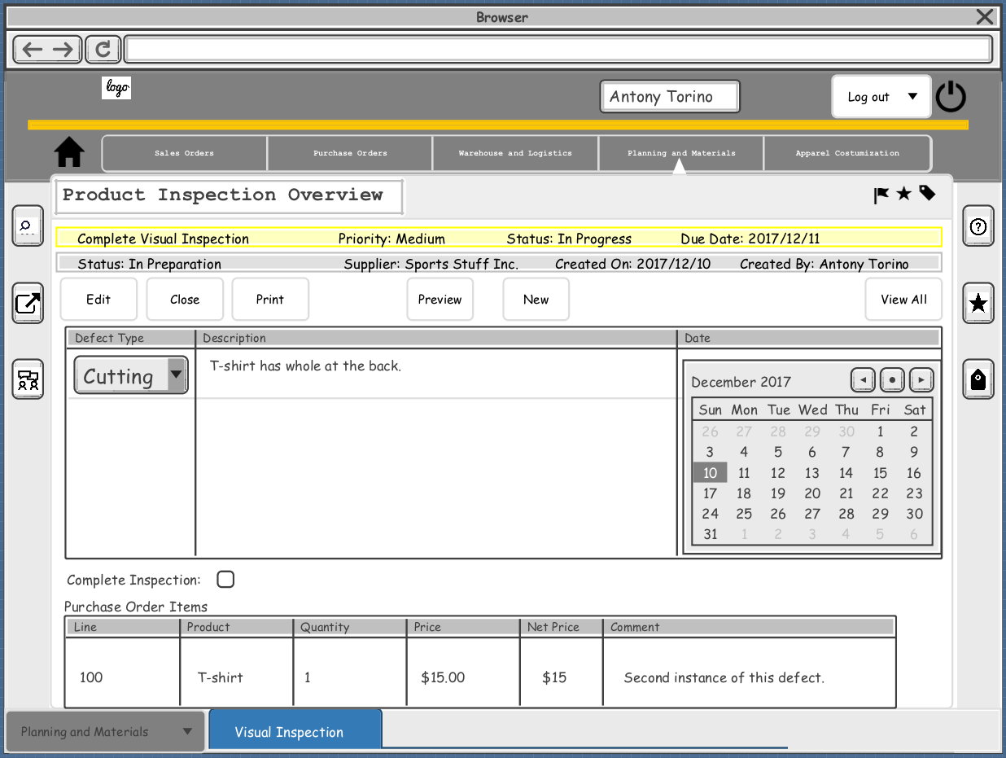 (Figure 6: Defect Types)

1. Defect Types is used after saving an inspection Form, in the new view variables appear in a dropdown list of the common defects. For example, cutting, assembling and pressing defects. It is only available for the user who created the view. The view can only be deleted by the user who created it.

**4.0 GRAPHICAL USER INTERFACES**

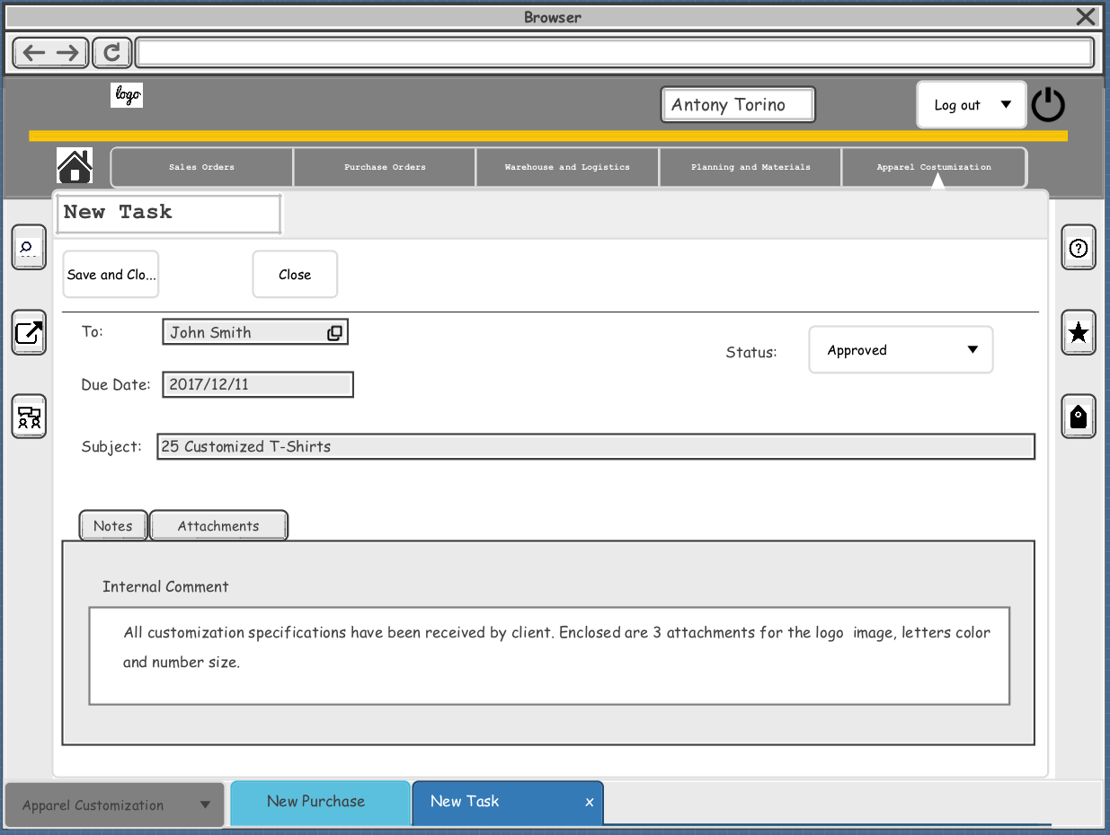 (Figure 7: Customization Service)

1. Status is used to monitor the work assigned. Example: if the personalization details are confirmed by client and agreed by Silk Thread the sales transaction can be released by the system
2. **REPORTS**

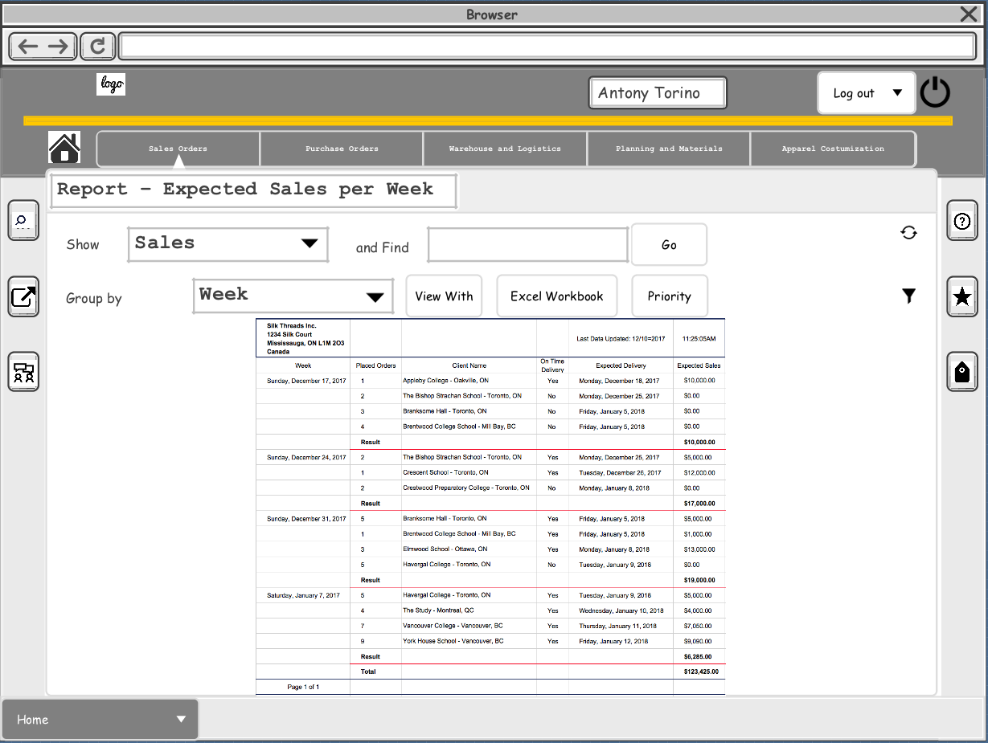

(Figure 8: Report – Expected Sales per Week)

Shows the expected shipments of sale order per week for the next 4 weeks.

**5.0 REPORTS (CONTINUED)**

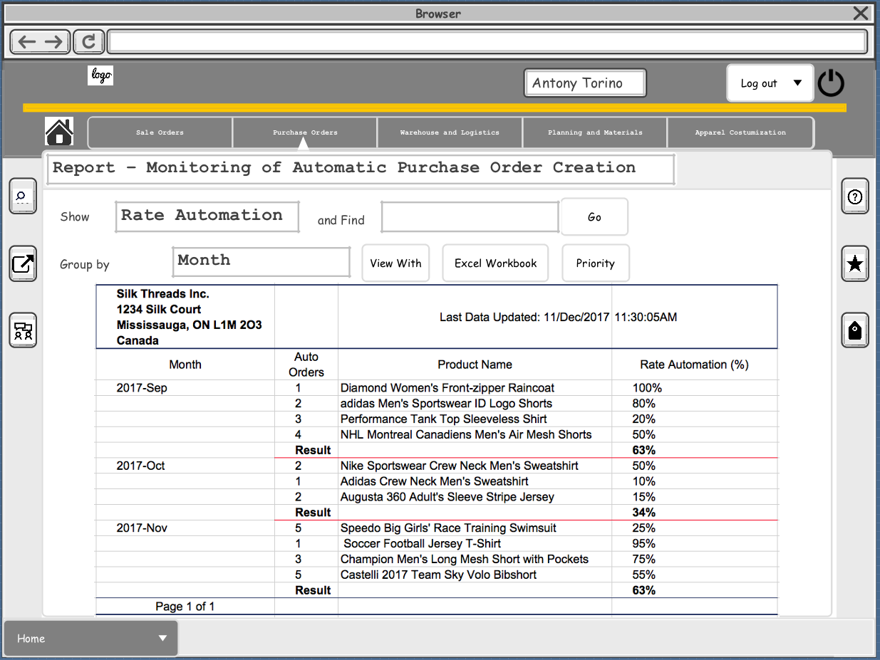

(Figure 9: Report – Monitoring of Automatic Purchase Order Creation)

Shows the percentage of automatically created purchase orders per purchasing item over the last 3 months and the corresponding purchasing value. Silk Threads can check the degree of purchasing automation for a single or for all purchasing items.

**5.0 REPORTS (CONTINUED)**

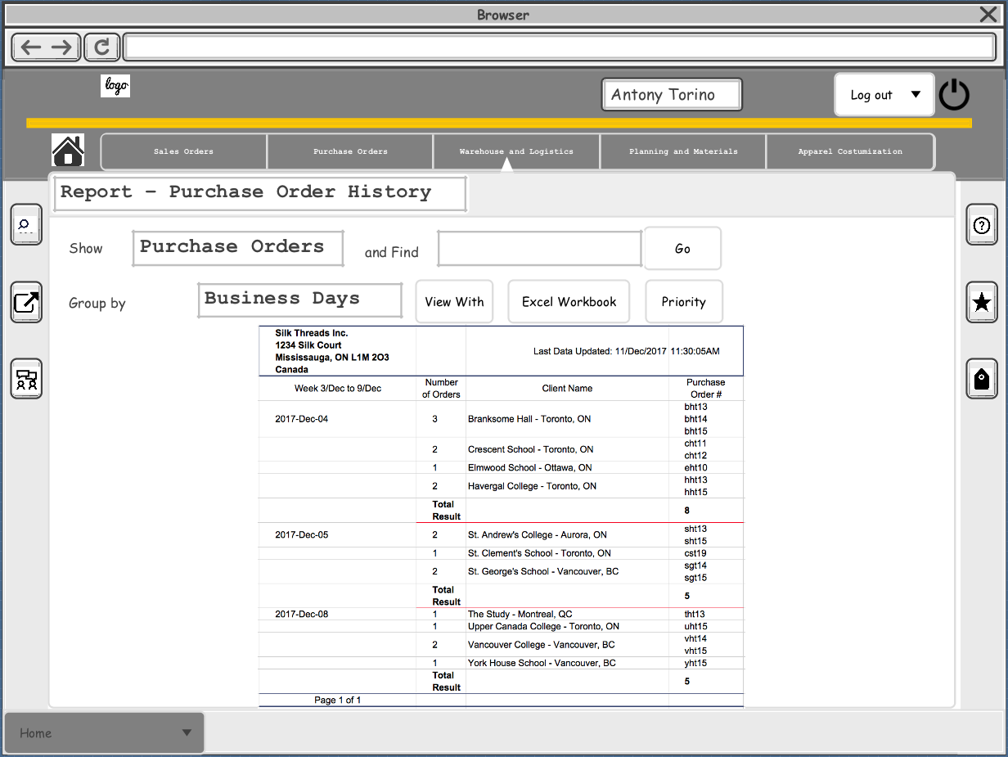

(Figure 10: Report – Purchase Order History)

Shows all purchase orders that have been created during the last week. The user can track follow up documents such as goods and service receipts, returns, vendor invoices, and credit memos regarding quantities, values, and duties.

**5.0 REPORTS (CONTINUED)**

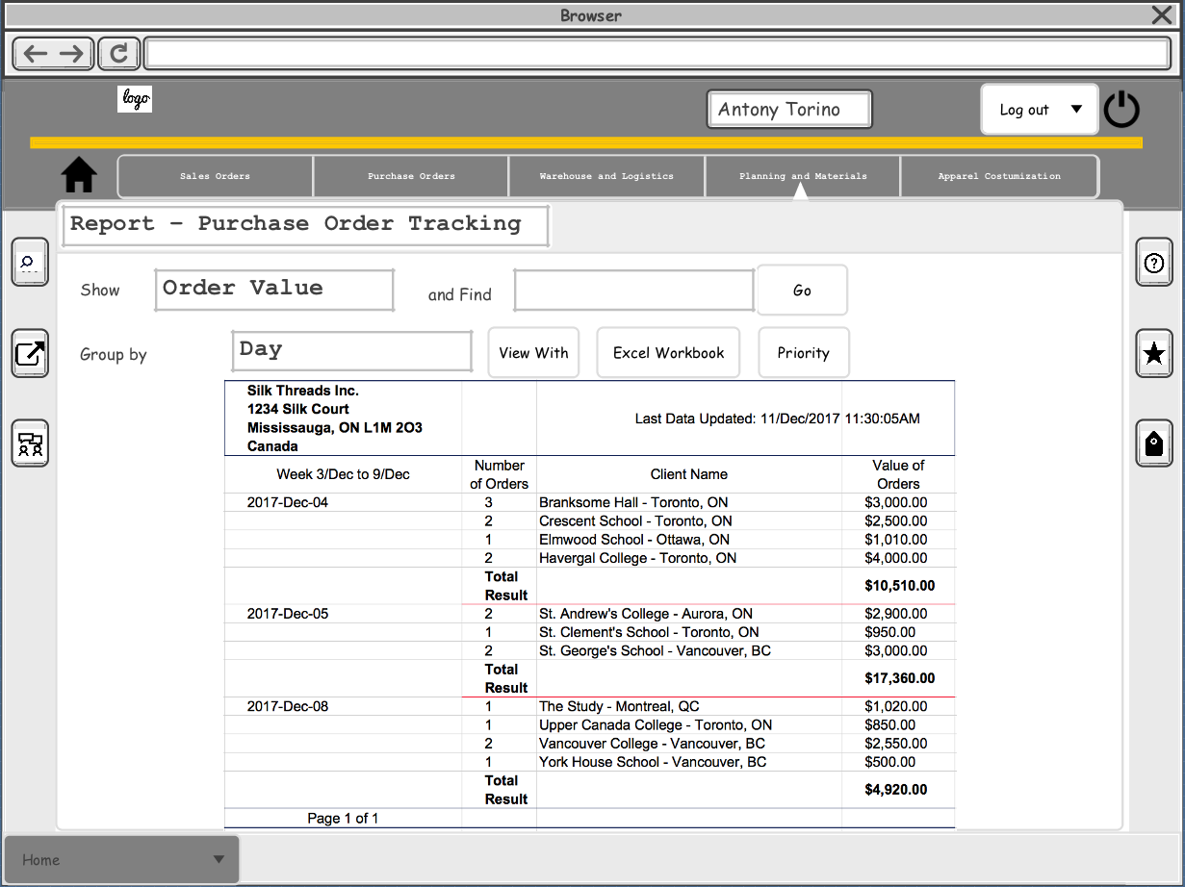

(Figure 11: Report – Purchase Order Tracking)

Shows all purchase orders that have been created during the last week. Silk Threads can check the purchase order value, price, quantity, and status of the purchase order.

**5.0 REPORTS (CONTINUED)**

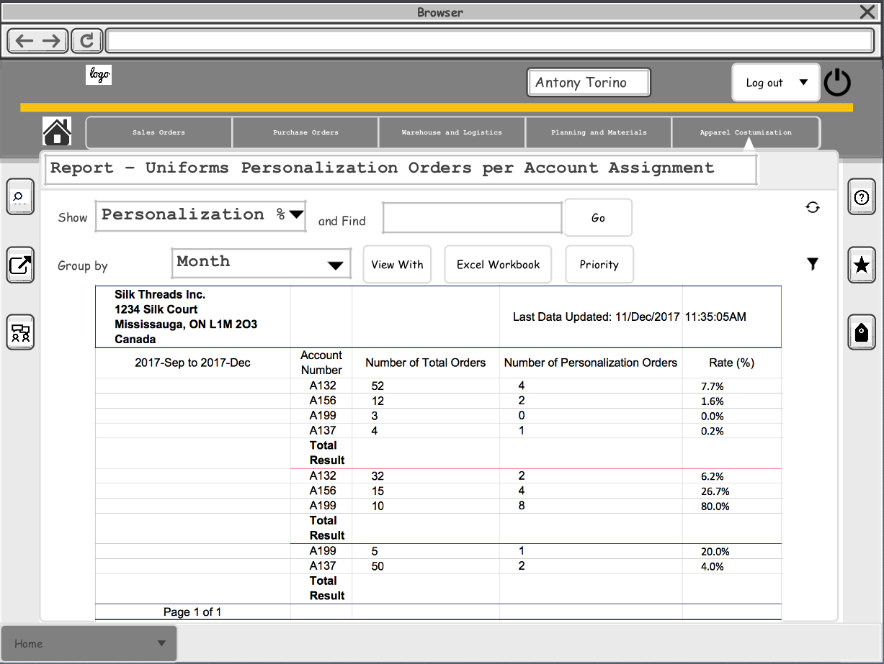

(Figure 12: Report – Uniforms Personalization Orders per Account Assignment)

Shows all uniform personalization orders per account assignment. Silk Threads can track the total values per account assignment and the status of the work order.

1. **RECOMMENDATIONS**

Electronic information is essential in order to be able to make smart business decisions at Silk Threads. The proposed new website will help the business grow by implementing an automated data entry. Silk threads will be able to serve more customers more efficiently. It summarizes all the relevant data required to complete online sales transactions and therefore make the shopping experience more convenient for the customers. an investment in this system is needed Integrating sports apparel vendors in the website gives a business advantage Silk Threads by reducing purchase costs and providing cooler sports uniforms. Work Chapters are tools for organising multiple functions in the business in groups of processes. Introducing the new sub-menus into the system makes jobs at Silk threads more rewarding, logical and significant.

This website superseded the traditional business model and makes Silk Threads a dot-com (.com) company that does its primary business using the Internet. It is designed with internal and external control features, to guarantee that the business system will be consistent, correct, maintainable, and safe. The next project is generation of cost benefit analysis report.

1. **REVISION HISTORY**

|  |  |
| --- | --- |
| Document Control ID: | Reason for Change |
| PETROVSKI-NSUR-123-R0 | New document |